A company Logo (1 Marks: External Documentation).

b. Table of Contents (1 Marks: External Documentation).

d. Detailed Game Description – describing how your game works (2 Marks: External Documentation).

Player is dragged using touch, player must avoid the rocks and eventually reach where the bottle(Win condition) is. Player has 3 lives, and each time player touches the rock, player loses 1 life and when reach 0 life, player loses.

e. Controls : Control is done via touch, dragging player to where the win condition (In this case, the bottles are) is.

f. Interface Sketches – this section should include wireframes of each of your game screens (Menu Screen, Instructions Screen, Game-Play Screen, Game Over Screen) with appropriate labels. Please use an appropriate tool to create these. Hand-drawn sketches will not be accepted. This is an important part of the planning process for your game. (8 Marks: External Documentation)

Main Menu

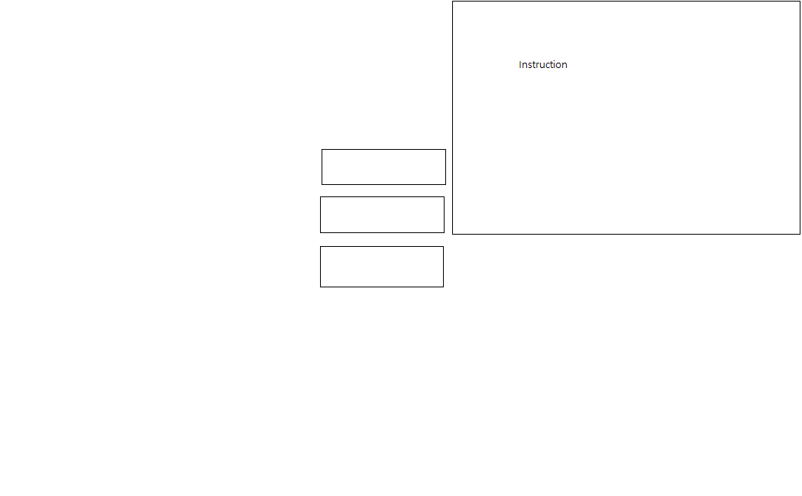

Other Menus Such as Win/Lose Menu



g. Screen Descriptions – Include at least 4 screen shots for your game: 1 for your Start Screen, 1 for your Gameplay Screen, 1 for your Game-End Screen and 1 for each level of difficulty (4 Marks: External Documentation).

Main Screen

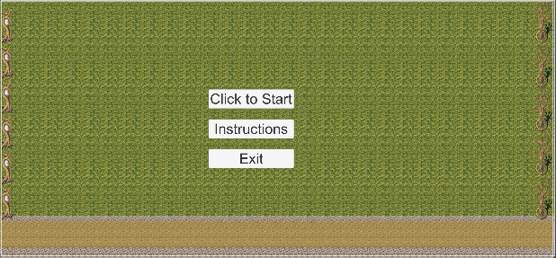

Instruction Screen

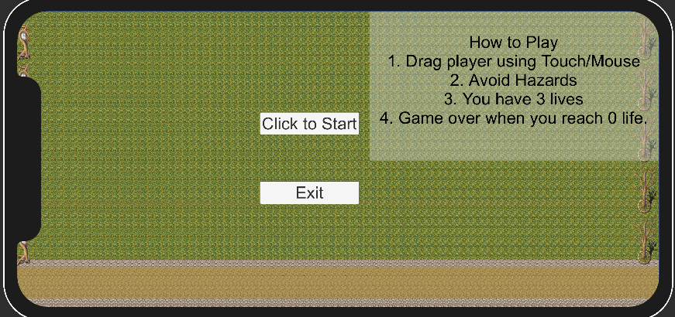

Gameplay Screen

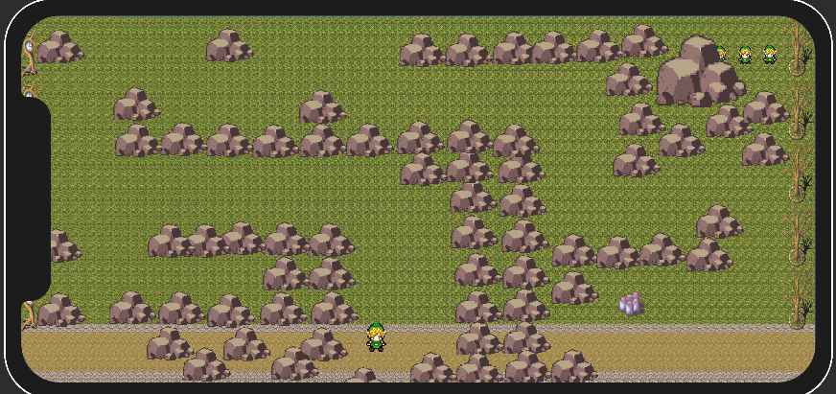

h. Game World – Describe your game environment (1 Mark: External Documentation).

Game will have grass background; player cannot go beyond the borders (or screen). Rocks exist as hazards.

i. Levels – Describe each of your game levels or challenge levels. (1 Marks: External Documentation).

Level will consist of single level, (hopefully more levels in the future). Every time the player reaches it’s destination, player will be moved on to the next level.

j. Characters / Vehicles – Describe the character’s Avatar (1 Mark: External Documentation).

Character is Link from Zelda. It currently has idle animation.

k. Enemies (AI) – Describe the computer-controlled enemies (AI) and how they function. Describe their desired behaviour (2 Marks: External Documentation).

No AI, just hazards in this game.

l. Weapons – Describe any weapons available to the player (1 Mark: External Documentation).

No Weapon available for player, everything must be avoided.

m. Scoring (or Progression) – Describe how the player can score (or progress in the game) and how this is calculated (1 Mark: External Documentation).

Player can score by reaching it’s destination. (Win)

n. Sound Index – Include an index of all your sound clips (1 Mark: External Documentation).

<https://opengameart.org/content/punch>

<https://opengameart.org/content/town-theme-rpg>

o. Art / Multimedia Index – Include examples of your image assets. Each image should be displayed as a thumbnail (1 Mark: External Documentation).